**JSS SCIENCE AND TECHNOLOGY UNIVERSITY**

**MYSURU 570 006**

**SRI JAYACHAMARAJENDRA COLLEGE OF ENGINEERING**



**PROJECT REPORT as a part of CIE event for the course**

**EC350:**

**Course Instructor: KavyaShree M.K**

**Project Title: Controlled Automation using Bluetooth and motion Detector**

Submitted by

|  |  |  |  |
| --- | --- | --- | --- |
| **SL NO** | **NAME** | **USN NO** | **SECTION** |
| 1 | KEERTHAN.S | 01JST16EC042 | B |
| 2 |  |  |  |
| 3 |  |  |  |
| 4 |  |  |  |

**Acknowledgement**

 We take this opportunity to express our profound gratitude and deep regards to our respected Asst. Prof. Kavyashree M K for her exemplary guidance, monitoring and constant encouragement throughout the course. Lastly, we would like to express our deep appreciation towards our classmates and our indebtedness to our parents for providing a moral support and encouragement.

**ABSTRACT**:

The project aims to replace conventional switches by the two-way controlled switch i.e., Mechanical and voice controlled. Motion detection which when implemented, enhances automation and hence energy conservation. A Bluetooth module HC-05 is interfaced with Arduino UNO microcontroller along with the motion detector circuit which is designed by us. The motion detector circuit ensures that no people are inside the room and switches off all the devices except those that are marked by the user. We are trying to create an easier interface so as to make it feasible for long distance control and a better alternative to manual control.

The basic purpose of a conventional switch is to save power whenever the device is not in use. But the recent study says that this very basic purpose of the switch is not served. This demands an alternative controlling device such as AI induced home automation which can effectively conserve power. There by making our home or a industry much smarter than before.

**TABLE OF CONTENTS**

**Sl. No Title Page No**

**1. Introduction………………………………………………………**

**2. System Requirements and Analysis……………………………. 2.1 Block Diagram………………………………………………….**

**2.2 Block Diagram Description…………………………………**

**2.3 Hardware Requirements…………………………………….**

**2.4 Software Requirements………………………………............**

**2.5 System Implementation………………………………………**

**3. Arduino Code……………………………………………………..**

**4. Advantages and Applications……………………………………**

**5. Result and Conclusion……………………………………………**

**1. INTRODUCTION**

Power management is one of the major issue in our day-to-day life. Some of the major sources of energy are thermal, nuclear, hydel and geothermal energy. If we study deeper, we will come to know that most of these energy does not come for nothing-but at the cost of environmental hazards. So, “if we can’t produce energy, let us at least conserve it”. Thereby reducing the ill-effects on environmental.

Today we are in a situation where the demand for any form of energy is increasing exponentially. Newer and better technologies have been implemented to produce energy for daily requirements. Even though all of these developments are taking place, we still are a long way from having completely sustainable energy source. The alternate approach is to save energy wherever possible. Our project gives the insight of one such approach.

**2. Requirements and Analysis**

**2.1.BLOCK****DIAGRAM**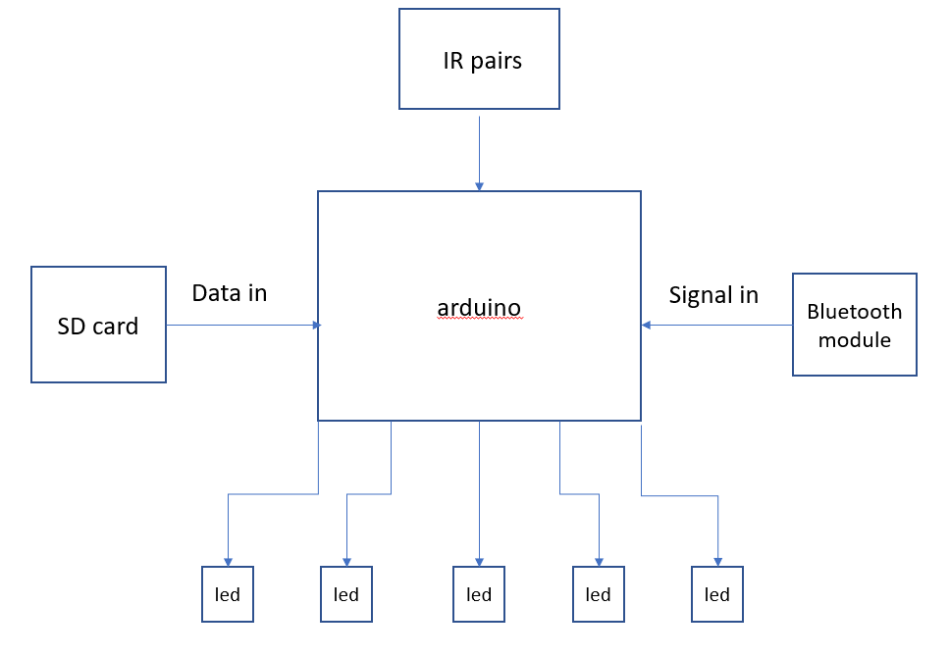

Figure 3.0

**2.2. Block Diagram Description**

The block diagram in the section 5.1 shows the IR pairs which control the power supply to the whole system which is in turn controlled by Arduino. The wireless commands are received via Bluetooth using the Bluetooth module. Then the data is compared with the ones stored in the program for further processing. Accordingly led are controlled using different commands. The leds here represent the different loads assigned with particular tasks

**2.3. Hardware Requirements**

* Arduino Uno :

A microcontroller that does all the processing work.

* LED :

Leds to indicate the specific task or the load within a system.

* IR pairs :

IR pairs keeps the count of number of persons entering the room. Turns of the mains automatically when no persons are present within the range specified.

* Jumper wires:

Connecting jumpers are used to connect the load to microcontroller.

* Breadboard:

Bread board here is used to mount all components and establish necessary connections between them.

* Bluetooth module:

Bluetooth module is interfaced with mobile application and the voice input through microphone is sent to microcontroller via Bluetooth.

Figure1.1 shows the bread board, Arduino, Bluetooth and some Leds. Figure 1.2 shows the Bluetooth module and some jumper wires.

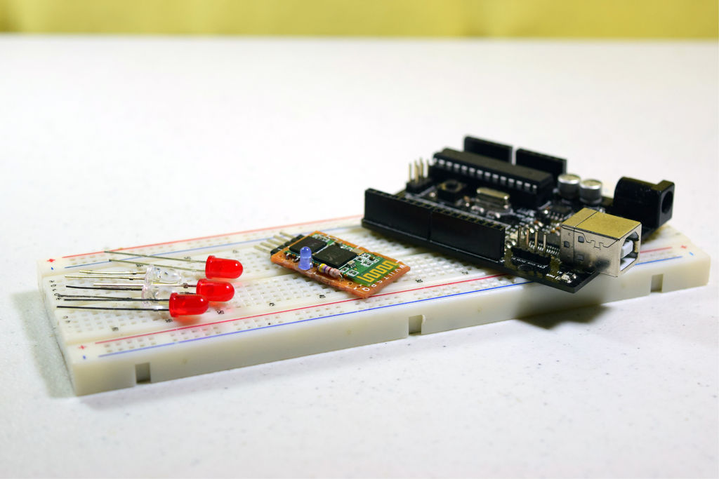

Fig 1.1

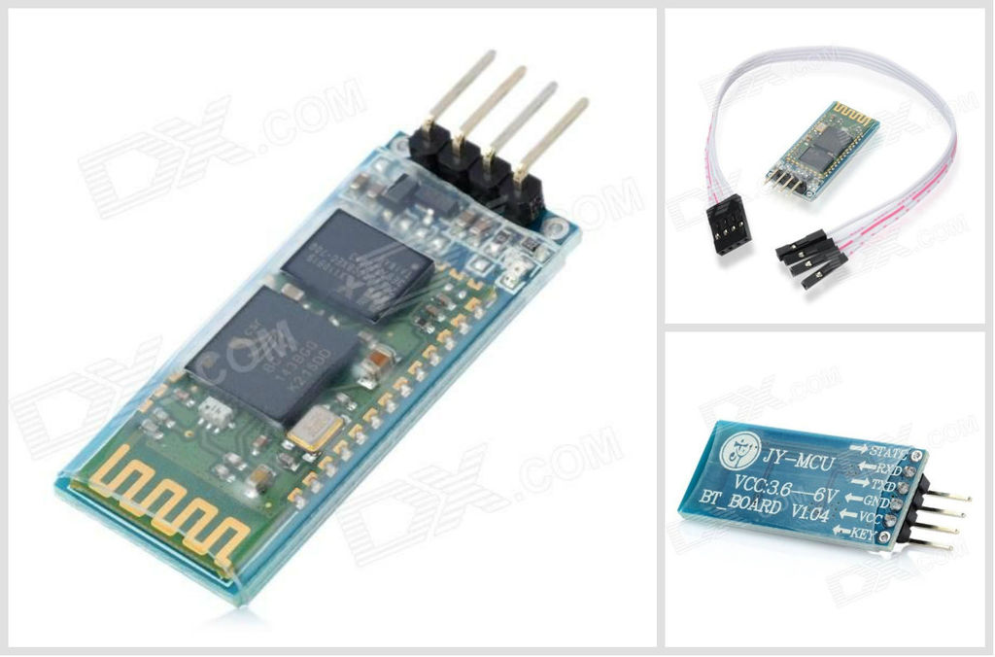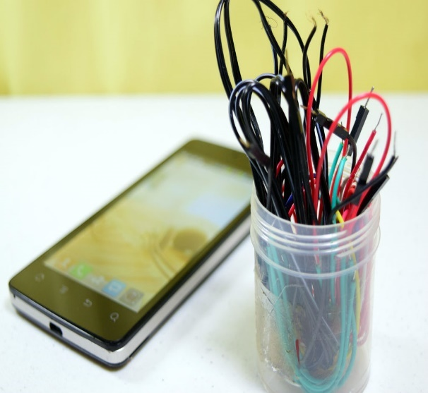

Fig1.2

**2.4. FLOWCHART:**

The data flow is showed in the figure 3.1 where the flow starts by taking the count of number of persons “N” getting inside or leaving. N is incremented to N+1 when person enters and decrements when the persons leaves. Next it checks the decision statement if N>0 , which means if atleast one person has entered it is ready to accept voice input. Voice input controls the load or the leds present. If N<0 which means if there are no person inside automatically all lights are turned off and the flow is terminated.

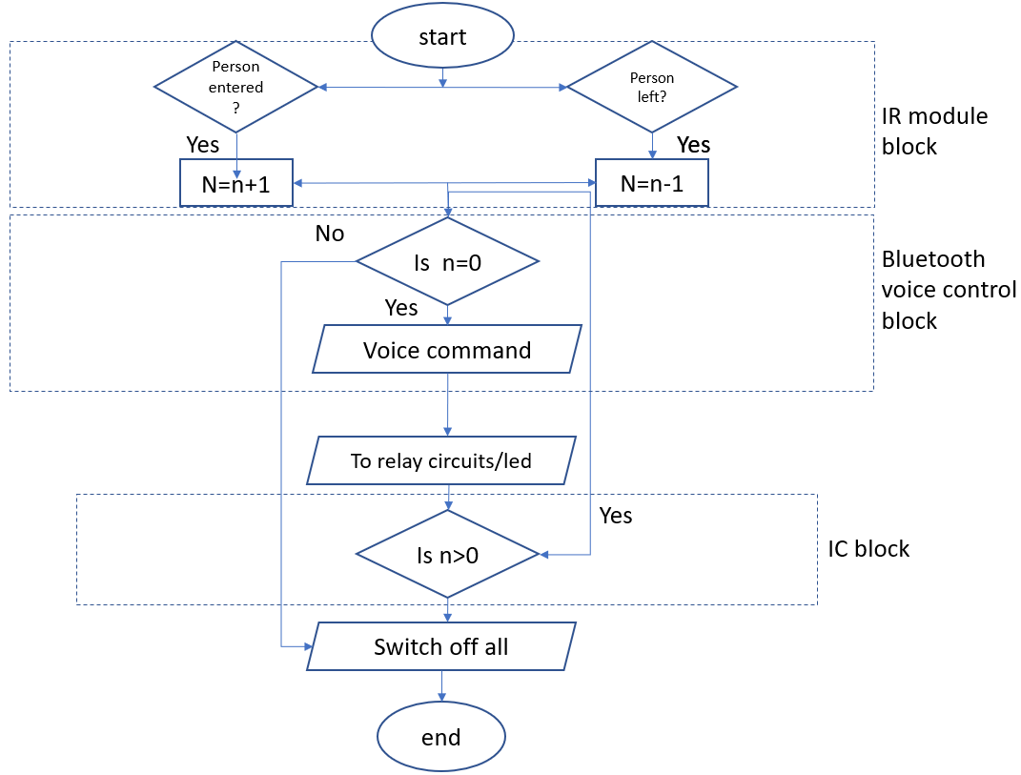

Figure 3.1

**2.5. Software Requirements**

The Arduino Integrated Development Environment - or Arduino Software (IDE) - contains a text editor for writing code, a message area, a text console, a toolbar with buttons for common functions and a series of menus. It connects to the Arduino and Genuino hardware to upload programs and communicate with them.

**2.6. System Implementation**

The first step involves the interfacing of Bluetooth module with Arduino. The data required for processing is controlled using mobile application where voice signals are taken in as input. Figure 2.1 shows a brief idea for connections to be done. Now the respective leds are assigned according to various commands assigned in program.

The power management is also taken into consideration as the system gets on only when the IR pairs are triggered by the obstacle that passes by them thereby making the IR receiver to lose their signal. The identification of whether the person is entering is entering or leaving is done by using two IR pairs in series and having a gap of 4 inches between them.

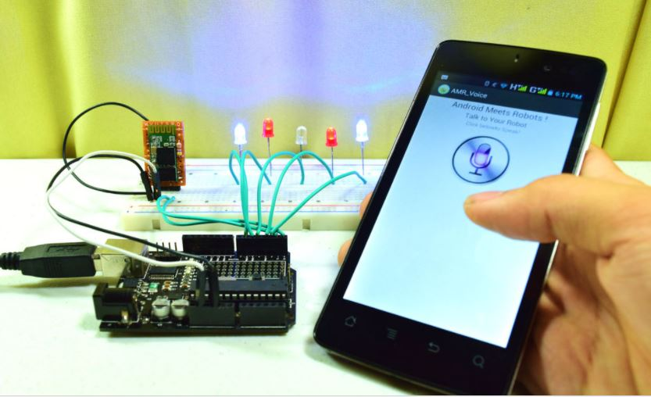

Fig.2.1

The order of triggering the IR pair is 1,2,3… this indicates that the person has entered the room, and when the order is 2,1,0.. the person is said to be leaving the room. Once when the person enters the room the Arduino is powered up, then the Bluetooth module gets paired up with the mobile. And the system is ready to take the voice input. This is shown in the block diagram in the section 4.1.

BT Voice control app:

Voice Recognition Uses android mobiles internal voice recognition to pass voice commands to your robot Pairs with Bluetooth Serial Modules and sends in the recognized voice as a string for example let’s say you give a command “tv on”. The command is processed and is sent via Bluetooth to the Arduino where in the data is matched with the one stored. Once the match is found the respective action is performed. This is showed in Figure 2.2.

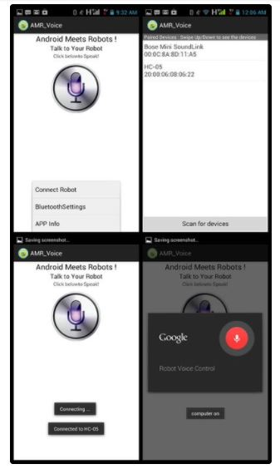

Fig.2.2

**3. ARDUINO CODE:**

#define in 11

#define out 10

int n=0;

int i;

String voice;

led1 = 2, //Connect LED 1 To Pin #2

led2 = 3, //Connect LED 2 To Pin #3

led3 = 4, //Connect LED 3 To Pin #4

led4 = 5, //Connect LED 4 To Pin #5

//--------------------------Call A Function------------------//

void allon()

{

digitalWrite(led1, HIGH);

digitalWrite(led2, HIGH);

digitalWrite(led3, HIGH);

digitalWrite(led4, HIGH);

}

void alloff()

{ digitalWrite(led1, LOW);

digitalWrite(led2, LOW);

digitalWrite(led3, LOW);

digitalWrite(led4, LOW);

}

void IN()

{ n++;

delay(1000);

Serial.print(n);}

void OUT()

{ n--;

delay(1000);

Serial.print(n);

}

void setup() {

Serial.begin(9600);

pinMode(led1, OUTPUT);

pinMode(led2, OUTPUT);

pinMode(led3, OUTPUT);

pinMode(led4, OUTPUT);

pinMode(in,INPUT);

pinMode(out,INPUT);

Serial.print(n);

}

void loop()

{

if(digitalRead(in))

IN();

if(digitalRead(out))

OUT();

if(n>0)

{

while (Serial.available())

{ delay(10); //Delay added to make thing stable

char c = Serial.read(); //Conduct a serial read

if (c == '#') {break;} //Exit the loop when the # is detected after the word

voice += c; //Shorthand for voice = voice + c

}

if (voice.length() > 0)

{

Serial.println(voice);

//----------Control Multiple Pins/ LEDs----------//

if(voice == "*all on") { allon(); } //Turn Off All Pins

else if(voice == "*all off”) { alloff(); } //Turn On All Pins

//----------Turn On One-By-One----------//

else if(voice == "*TV on") {digitalWrite(led1, HIGH);}

else if(voice == "*fan on") {digitalWrite(led2, HIGH);}

else if(voice == "*computer on") {digitalWrite(led3, HIGH);}

else if(voice == "*lights on") {digitalWrite(led4, HIGH);}

//----------Turn Off One-By-One----------//

else if(voice == "*TV off") {digitalWrite(led1, LOW);}

else if(voice == "*fan off") {digitalWrite(led2, LOW);}

else if((voice == "*computer off")|(voice == "*computer of"))

{ digitalWrite(led3, LOW); }

else if(voice == "*lights off") { digitalWrite(led4, LOW); }

voice="";}

}

else

alloff();

}

**4. ADVANTAGES AND APPLICATIONS:**

**1. Managing all of your home devices from one place.** The convenience factor here is enormous. Being able to keep all of the technology in your home connected through one interface is a massive step forward for technology and home management.

**2. Flexibility for new devices and appliances.** Smart home systems tend to be wonderfully flexible when it comes to the accommodation of new devices and appliances and other technology. No matter how state-of-the-art your appliances seem today, there will be newer, more impressive models developed as time goes on.

**3. Maximizing home security.** When you incorporate security and surveillance features in your smart home network, your [home security can skyrocket](http://www.adt.com/resources/benefits-of-smart-homes-technology). There are tons of options here -- only a few dozen of which are currently being explored. For example, home automation systems can connect motion detectors, surveillance cameras, automated door locks, and other tangible security measures throughout your home so you can activate them from one mobile device before heading to bed

**5. Increased energy efficiency.** Depending on how you use your smart-home technology, it’s possible to make your space more energy-efficient.

**6. Improved appliance functionality.** Smart homes can also help you run your appliances better. A smart TV will help you find better apps and channels to locate your favorite programming.

**7. Home management insights.** There’s also something to be said for your ability to tap into insights on how your home operates. You can monitor how often you watch TV (and what you watch), what kind of meals you cook in your oven, the type of foods you keep in your refrigerator, and your energy consumption habits over time

**4. RESULT AND CONCLUSION:**

This concept of controlled automation has a great scope in domestic and industrial power supply and management as power conservation is the need-for-the-hour. As the power used in industries are very high, power losses for few hours causes a huge energy loss, the automation is a necessary technique. Since automation alone cannot ensure proper execution and power management in a huge system such as an industry or a house, we need to employ a new technique of controlled automation.

This concept can be further extended to a remotely accessible smart socket using GSM module which can be scheduled to work for a period of time. The concept of controlled automation, when implemented on a large scale will give us high returns in terms of power saving and efficient usage in domestic and industrial application

The system was designed and was checked for the all kinds of voice commands and the output were verified. The project gave an insight into the effect usage of sensors and actuators in day today life.